7COM1079-0901-2025 - Team Research and Development Project

Final report title: World Happiness Report

Group ID: G141

Dataset number: ds218

Prepared by: Noor Eltafahny 21038413,
Haider Ali 24065270,
Seikh Fuyad Sakib 24090212,
Muhammad Bilal Khan 24089897,
Rana Zeeshan Ali 2400292,

University of Hertfordshire
Hatfield, 2025

Table of Contents

- Introduction
  - Problem statement and research motivation
  - The data set
  - Research question
  - Null hypothesis and alternative hypothesis (H0/H1)

- Background research
  - Research papers
  - Why RQ is of interest (research gap and future directions according to the literature)

- Visualisation
  - Appropriate plot for the RQ output of an R script and required supplementary graph/
  - Additional information relating to understanding the data
  - Useful information for the data understanding

- Analysis
  - Statistical test used to test the hypotheses and output
  - The null hypothesis is rejected based on the p-value

- Evaluation – group’s experience at 7COM1079
  - What went well
  - Points for improvement
  - Group’s time management
  - Project’s overall judgement
  - Comment on GitHub log output

- Conclusions
  - Results explained.
  - Interpretation of the results
  - Reasons and implications for future work, limitations

- Reference list
- Appendices
- R code used for analysis and visualisation.
- GitHub log output.

- Introduction

  - Problem statement and research motivation
Understanding what drives national happiness is increasingly important for politicians and researchers, as wellbeing is linked to social cohesion, public health, and broader societal development. Economic prosperity is often assumed to enhance happiness, yet evidence suggests the relationship is not always consistent. Helliwell, Layard and Sachs (2019) note that while income contributes to wellbeing, it does not fully explain why levels of happiness differ so widely across countries. This uncertainty highlights the need to examine how strongly national wealth influences subjective wellbeing. Therefore, this study investigates whether GDP per capita is positively associated with happiness levels in the 2019 World Happiness Report.

  - The data set
This study uses the 2019 World Happiness Report dataset produced by the United Nations Sustainable Development Solutions Network, based on survey responses from the Gallup World Poll. The dataset includes more than 150 countries and provides several explanatory indicators such as GDP per capita, social support, healthy life expectancy, generosity, and freedom of choice. For this analysis, only GDP per capita and the Happiness Score are used, enabling a focused investigation within the final pre-pandemic dataset.

  - Research question
This study addresses the following research question:
“Is there a positive correlation between GDP per capita and the Happiness Score in the 2019 World Happiness Report?”

The aim is to determine whether wealthier countries tend to report higher subjective wellbeing, and whether this association is statistically significant.

  - Null hypothesis and alternative hypothesis (H0/H1)
The study formulates the following theories to answer the research question:
Null Hypothesis (H₀): There is no correlation between GDP per capita and the Happiness Score in the 2019 World Happiness Report.
Alternative Hypothesis (H₁): There is a positive correlation between GDP per capita and the Happiness Score in the 2019 World Happiness Report.

- Background research
  - Research papers
Research on national wellbeing frequently draws upon the World Happiness Report and Gallup World Poll data to explore how economic factors influence happiness. Helliwell, Layard and Sachs (2019) used this dataset to demonstrate that GDP per capita reliably predicts cross-national differences in life satisfaction; however, they noted that income alone cannot fully explain variations in wellbeing, indicating the need to consider contextual and social factors.

Similarly, Diener et al. (2018) identified a positive association between national income and subjective wellbeing, but observed diminishing marginal effects in wealthier countries, suggesting that the GDP–happiness relationship is non-linear and influenced by economic development stages.

By contrast, Easterlin and O’Connor (2020) analysed long-term trends and found that increases in GDP do not consistently translate into higher national happiness, a pattern known as the “Easterlin Paradox”. This challenges the assumption that economic growth alone improves wellbeing.

Together, these studies demonstrate that while GDP per capita relates to happiness, the strength, shape, and stability of this relationship vary. This complexity provides strong justification for re-examining the relationship within specific datasets, such as the 2019 World Happiness Report.

  - Why RQ is of interest
Although many studies examine income and wellbeing, most focus on long-term or multi-year trends, leaving fewer investigations into how strongly GDP per capita predicts happiness within a single, stable year. This creates a research gap in understanding whether the relationship holds under consistent global conditions. The 2019 World Happiness Report is particularly valuable as it represents the final pre-pandemic dataset, unaffected by the economic and social disruptions that followed. Analysing this year provides a clear baseline for assessing the income–happiness link. Future studies could compare post-2020 data to explore how global crises alter this relationship.

- Visualisation
  - Appropriate graphs for the RQ
A scatterplot was chosen because it shows how the happiness score changes as GDP per capita changes across countries. The regression line summarises the overall linear trend between GDP per capita and happiness. Histograms show each variable’s distribution, helping to judge whether unusual values (outliers) may influence the correlation.
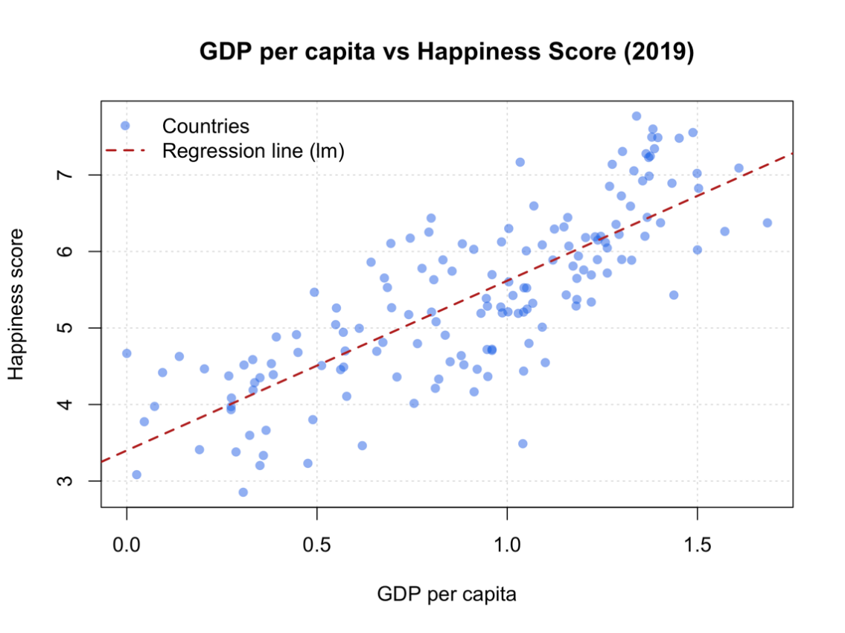

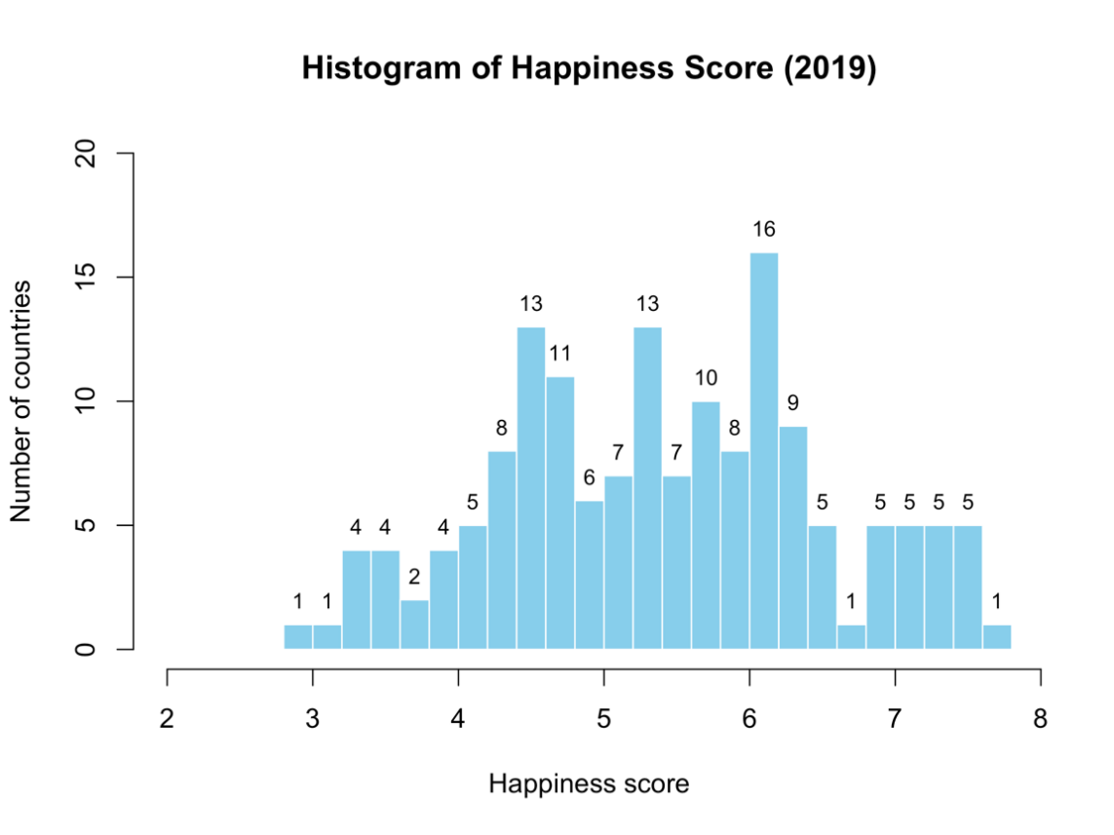

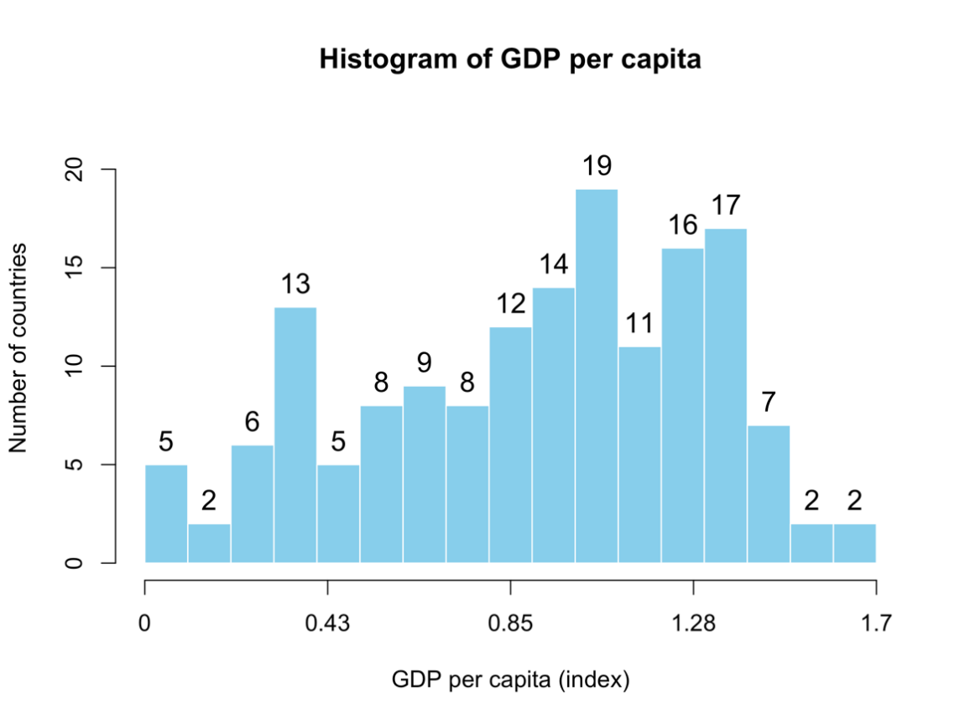
  - Additional information relating to understanding the data
The scatterplot shows whether countries with higher GDP per capita usually have higher happiness scores (each dot is a country). The regression line shows the overall straight-line trend. The histograms show how spread out the GDP and happiness values are and whether there are any unusual countries (outliers) that could affect the correlation.

  - Useful information for the data understanding
The scatterplot shows a clear positive relationship, countries with higher GDP generally report higher happiness scores. The pattern is mostly linear, but a few countries lie away from the main cluster. The GDP histogram values are mostly low to mid with a few very high values, while happiness scores are more in the mid-to-high range.

- Analysis
  - Statistical test used to test the hypotheses and output
This research question examines the strength and direction of the linear relationship between two continuous numerical variables: GDP per capita and Happiness Score. A Pearson correlation test is appropriate since both variables have an interval scale. The scatterplot showed a clear linear trend with no extreme normality violations. Pearson's test describes linear association and provides a p-value for hypotheses. Assumptions checked include linearity, approximate normality, and independence. The output reports r = 0.7939, indicating a strong positive linear relationship.

  - The null hypothesis is rejected based on the p-value
The Pearson correlation test gave a significant t-value: 16.202 with df = 154 and p-value < 2.2e-16, way below the 0.05 significance level. So, we can reject the null hypothesis and conclude that in the data of 2019, GDP per capita is positively related to the Happiness Score. Having r = 0.7939, the sample correlation is strong; this signifies that countries with higher per capita GDP tend to have higher reported happiness. Having 95% confidence, the true population correlation is likely to be a strongly positive value within the interval 0.7275 to 0.8455, thus supporting the alternative hypothesis.

- Evaluation – group’s experience at 7COM1079
  - What went well
Our team worked well together from start to finish, with everyone clearly assigned tasks that used each member’s strengths. We maintained open communication through messaging and online meetings, ensuring progress stayed visible to all. We selected a dataset that was manageable and relevant, making our statistical analyses meaningful. Using GitHub kept version control clear and contributions traceable. Defining the research question early provided direction, and initial exploration guided our visualisation choices while constructive feedback improved overall quality overall.

  - Points for improvement
The initial group meetings could have had a more organised format with clear agendas to achieve maximum efficiency. Some individuals struggled with programming in R, which created time constraints. An early consultation with module tutors could have reduced the need for later revisions. Documentation of decision-making processes could have included more detail for the final report. Setting clearer deadlines for each section of the report would have prevented last-minute stress and allowed more time for refinement and ensure quality.

  - Group’s time management
Time management showed good improvement. Although early stages were delayed in finalising the research question and dataset, confirming the analysis structure helped maintain momentum. Using a collaborative timeline with milestones worked well. The last two weeks were especially productive, and starting this period earlier would have helped reduce overall stress levels.

  - Project’s overall judgement
In conclusion, this project effectively addressed its tasks and has shown a marked and statistically significant positive correlation between GDP per capita and happiness scores. This analysis had strong methodology and proper interpretation. Despite minor time management challenges, the team produced a cohesive, academically rigorous report that enhances understanding of economic influences on national well-being.

  - Comment on GitHub log output
Appendix B contains a look at the GitHub log, which illustrates how our team worked together. A quick glance at Appendix B informs us that our team contributed throughout the project timeline. Commits were made when major milestones were reached concerning data analysis, visualisation, and report writing. Commit activity escalated during critical periods and modifications.
- Commit Message: "1st Commit"
Initial dataset upload and exploratory analysis. This commit established the project foundation, enabling all team members to work with standardised data files.
- Commit Message: " updated the visualisation section and add plots as well"
This critical commit added the final visualisation code, including scatterplots, completing the graphical representation of the data and supporting the analysis of the research hypotheses.
- Commit Message: " Submit final report: GDP-Happiness_correlation_analysis)"
This commit unified all sections, ensuring consistent formatting and cohesive narrative flow throughout the document.
- Conclusions
  - Results explained
The analysis of the 2019 World Happiness Report data revealed a strong and statistically significant positive correlation between GDP per capita and national happiness scores. The Pearson correlation value of r = 0.7939 indicates that countries with higher economic output tend to report higher levels of subjective wellbeing. The associated p-value, far below the 0.05 threshold, supports rejecting the null hypothesis. Overall, the findings demonstrate a clear relationship between economic wealth and self-reported national happiness.

  - Interpretation of the results
These results suggest that economic wealth is an important contributor to national wellbeing, supporting the idea that higher income levels can improve quality of life by enhancing access to resources, stability, and opportunities. However, the scatterplot and confidence interval indicate that whilst the relationship is strong, it is not perfect, implying that GDP alone does not fully determine happiness. Along with economic data, other factors that affect wellbeing include life expectancy, freedom of choice, and social support.

  - Reasons and implications for future work, limitations of the study
This study is limited by the fact that it only looks at two variables and analyses data from a single year, leaving out important social and cultural aspects. To evaluate how non-economic factors interact with GDP in shaping national happiness, future research may examine multi-year patterns, compare datasets collected before and after the pandemic, or use multivariate models.

- Reference list

- Helliwell, J.F., Layard, R. & Sachs, J. (2019) World Happiness Report 2019. New York: Sustainable Development Solutions Network. Available at: https://worldhappiness.report/ed/2019/ (Accessed: 10 December 2025).
- Diener, E., Oishi, S. & Tay, L. (2018) Advances in subjective well-being research. Nature Human Behaviour, 2(4), pp.253–260. Available at: https://doi.org/10.1038/s41562-018-0307-6 (Accessed: 10 December 2025).
- Easterlin, R.A. & O’Connor, K.J. (2020) The Easterlin Paradox. IZA Discussion Paper No. 13923. Bonn: IZA Institute of Labor Economics. Available at: https://www.iza.org/publications/dp/13923/the-easterlin-paradox (Accessed: 10 December 2025).

- Appendices

Appendix A: R Code for Statistical Analysis and Visualization
This appendix contains the complete R code used to test the hypothesis examining the relationship between GDP per capita and happiness scores using the 2019 World Happiness Report dataset.

# ----------------------------------------------------------
# 1) Load and prepare data
# ----------------------------------------------------------

df <- read.csv("2019.csv", check.names = FALSE)

# Rename the columns names
# Rename the 2nd column "Country or region" of df to "country"
colnames(df)[2] <- "country"
# Rename the 3rd column "Score" of df to "happiness"
colnames(df)[3] <- "happiness"
# Rename the 4th column "GDP per capita" of df to "gdp"

colnames(df)[4] <- "gdp"

# Removes rows containing null/NA values.
df <- na.omit(df)

df

# ----------------------------------------------------------
# 2) Main Plot = Scatterplot with Regression line
# ----------------------------------------------------------
#png("scatterplot.png", width = 1200, height = 900)

png("scatterplot.png",
width = 8, height = 6, units = "in", res = 300,
pointsize = 14)

# Regression line fitting from a linear model
fit <- lm(happiness ~ gdp, data=df)
par(cex=1.2)
# Plot with colors
plot(df$gdp, df$happiness,
pch = 16,
col = rgb(0.1, 0.4, 0.9, 0.55), # semi-transparent blue points
xlab = "GDP per capita",
ylab = "Happiness score",
main = "GDP per capita vs Happiness Score (2019)",
panel.first = grid(col = "grey85", lty = "dotted"))

# use to draw the regression line (red dashed line)
abline(fit, lwd = 2, lty = 2, col = "firebrick")

#lines(lowess(df$gdp, df$happiness), lwd = 2, col = "darkgreen") # green smooth

legend("topleft",
legend = c("Countries", "Regression line (lm)"),
pch = c(16, NA),
lty = c(NA, 2),
lwd = c(NA, 2),
col = c(rgb(0.1, 0.4, 0.9, 0.55), "firebrick"),
bty = "n")
dev.off()

# ----------------------------------------------------------
# 3) HISTOGRAMS (Check normality for choosing test)
# ----------------------------------------------------------

# ----------------------------------------------------------
# Happiness Histogram: Dependent variable (outcome)
# ----------------------------------------------------------
#png("hist_happiness.png", width = 1200, height = 900)

png("hist_happiness.png",
width = 8, height = 6, units = "in", res = 300,
pointsize = 14)

h <- hist(df$happiness, breaks = 20, plot = FALSE)
xmax <- max(h$breaks)
ymax <- max(h$counts)

hist(df$happiness,
breaks = h$breaks,
xlim = c(2, xmax),
ylim = c(0, ymax * 1.25),
main = "Histogram of Happiness Score (2019)",
xlab = "Happiness score",
ylab = "Number of countries",
col = "skyblue",
border = "white")

# Add count labels on top of each bar
text(x = h$mids,
y = h$counts,
labels = h$counts,
pos = 3, # above the bar
cex = 0.8,
col = "black")

dev.off()

# ----------------------------------------------------------
# GDP Histogram : Independent variable (predictor)
# ----------------------------------------------------------

h2 <- hist(df$gdp, breaks = 20, plot = FALSE)
#use seq to create ticks for the x-axis
ticks <- seq(0, max(h2$breaks), length.out = 5)

png("hist_gdp.png",
width = 8, height = 6, units = "in", res = 300,
pointsize = 14)

#png("hist_gdp.png", width = 1200, height = 900)

hist(df$gdp, breaks = h2$breaks,
xlim = range(ticks),
ylim = c(0, max(h2$counts) * 1.15),
main = "Histogram of GDP per capita",
xlab = "GDP per capita (index)",
ylab = "Number of countries",
col = "skyblue", border = "white",
xaxt = "n")

axis(1, at = ticks, labels = round(ticks, 2))

text(x = h2$mids,
y = h2$counts,
labels = h2$counts,
pos = 3,
cex = 1.2,
col = "black")

dev.off()

# ------------------------------------------------------------
# 4) Correlation Test: pearson (After checking histograms)
# ------------------------------------------------------------

cor_out <- cor.test(df$gdp, df$happiness, method = "pearson")

r <- unname(cor_out$estimate)
#person r
p <- cor_out$p.value
#p-value
n <- nrow(df)
#number of rows used in test

cat("\n--- Correlation test ---\n")
#print full test results
print(cor_out)

cor_out <- cor.test(df$gdp, df$happiness, method = "pearson")
print(cor_out)

# ------------------------------------------------------------
# 5) Summary statistics
# ------------------------------------------------------------
summary_table <- data.frame(
n = n,
happiness_mean = mean(df$happiness),
happiness_sd = sd(df$happiness),
happiness_min = min(df$happiness),
happiness_max = max(df$happiness),
gdp_mean = mean(df$gdp),
gdp_sd = sd(df$gdp),
gdp_min = min(df$gdp),
gdp_max = max(df$gdp)
)

cat("\n--- Summary table ---\n")
print(summary_table)

Appendix B: GitHub log output.

* 78d7780 Submit final report: GDP-Happiness correlation analysis (2019)
* b33aa3a updated code in docs
* 1af0ce2 Finalised the code.
* baa727f create and add the git log output
* 0415f28 Updated final report
* 462077f Updated the word count of section 3
|\
| * 72052ee change in 5.2
* | abc91cb Change word count in accordance with the limit.
|/
* 62cd30e updated report for word count compliance
* ef92beb Updated
* 2ea45b1 update
* a23d70e Updated report: fixed layout formatting and added new edits to the introduction
* ddc741f Updated final report with correct conclusion and fixed duplicate
* dd40a7f arrange 1.3
|\
| * 04d07ea updated the visualisation section and add plots as well
| * f748630 updated code for plot size and resoultion modificaion
| * 085c8b6 Updated the size and resolution of all the plots
| * fa2a020 Remove the smooth curve line from the scatterplot and generated the new plot.
* | 71e1495 test changes
|/
* ad261a6 update id
* 861e5c2 Removed the contingency table as histogram is added and which is a better choice by the analysis
* d7fa3be Add the comments for columns rename and save the Histogram of GDP with updated axis in PNG format
* ee02e44 Fix the issue of (Histogram of GDP) x-axis which is cutting off at the end and update the formatting and position of the sections according to the requirements.
* c44a6e3 evaluation changes
* fee57bf updated document
|\
| * 7989cb6 Added full conclusion to final report
| * 34d8f88 Delete 7COM1079_Final report (2).docx
| * e26edd6 presentation
| * 5312989 clean
| * c57f592 Added full conclusion section to final report
* | eaf17c6 updated document
|/
* 0625bb7 evaluation: git output comment
* 455ed9d evaluation: overall judgement
* 2ae4c37 Evaluation : Groups_Time_Management
* a761339 Evaluation : point_for_improvement
* 82032ef Evaluation :what went well
* 88f529e modified stistical hypothesis
* 2ff3565 added my ID
* e8c75c2 analysis written with statistical tests and hypothesis
* 8c8d95a generate graph for scatterplot
* 7159027 generate graphs in png format
* b1edd83 delete screenshot
* 1412e5e delete temp
* 4c354dc Cleaned code and commented
* 16df688 Merge pull request #1 from sfmsakib1/haider/visual
|\
| * e7a8738 saving new updated image of scatter plot
| * 14147f9 update the scatter plot makes it more cleaner and readable by removing excessive information
| * 16e28f7 update the scatterplot and add the image agian
| * 9c00ef9 generate histograms form the code and store result as a image
| * 3286554 saved the scatterplot generated from the output of the code
| * de49609 also added contingency table which shows propotions for both gdp and score columns
| * f2588be added two histograms for comparison of propotions among score and gdp
| * 9246c72 added the scatter plot with regression line with labels and some important information on the plot
| * 88dd6e4 added the summary table by which have mean,sd,min and max of both score and GDP columns
| * 3207263 add the person test for the data displaying pearson r, p-value, and number of rows.
| * 3e208f3 start working with the dataset and preprocess it for the futhur work
* | 1d19188 Added section 2.2
* | eceeedf merge
|\ \
| * | d9a2ab9 Added Section 2 Background Research
* | | 5bd178f ID added
|/ /
* | 9b38d40 delete duplicate
* | 31aa6e6 Added Section 1 Introduction
|/
* ad1d737 template file added
* a9548e7 git ignore file added
* a9d9ea8 check
* 953b6a0 1st commit

